**ST.XAVIER,S COLLEGE**

**Maitighar, Kathmandu**

**(Affiliated to Tribhuwan University)**



**LAB ASSIGNMENT #10-2**

**Submitted by:**

Abhishek Tamrakar

013BScCSIT003

2nd year/ 4th semester

**Submitted to:**

|  |  |
| --- | --- |
| **Er. Sanjay Kumar Yadav**  (Lecturer, St.Xavier’s College ) |  |

**DATABASE CONCURRENCY CONTROL**

1. **Purpose of Concurrency Control**

In a multiprogramming environment where multiple transactions can be executed simultaneously, it is highly important to control the concurrency of transactions. We have concurrency control protocols to ensure atomicity, isolation, and serializability of concurrent transactions. Concurrency control protocols can be broadly divided into two categories −

* Lock based protocols
* Time stamp based protocols

1. **Lock-based Protocols**

Database systems equipped with lock-based protocols use a mechanism by which any transaction cannot read or write data until it acquires an appropriate lock on it. Locks are of two kinds −

* **Binary Locks** − A lock on a data item can be in two states; it is either locked or unlocked.
* **Shared/exclusive** − This type of locking mechanism differentiates the locks based on their uses. If a lock is acquired on a data item to perform a write operation, it is an exclusive lock. Allowing more than one transaction to write on the same data item would lead the database into an inconsistent state. Read locks are shared because no data value is being changed.

There are four types of lock protocols available −

**Simplistic Lock Protocol**

Simplistic lock-based protocols allow transactions to obtain a lock on every object before a 'write' operation is performed. Transactions may unlock the data item after completing the ‘write’ operation.

**Pre-claiming Lock Protocol**

Pre-claiming protocols evaluate their operations and create a list of data items on which they need locks. Before initiating an execution, the transaction requests the system for all the locks it needs beforehand. If all the locks are granted, the transaction executes and releases all the locks when all its operations are over. If all the locks are not granted, the transaction rolls back and waits until all the locks are granted.

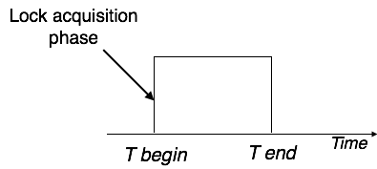

**Two-Phase Locking 2PL**

This locking protocol divides the execution phase of a transaction into three parts. In the first part, when the transaction starts executing, it seeks permission for the locks it requires. The second part is where the transaction acquires all the locks. As soon as the transaction releases its first lock, the third phase starts. In this phase, the transaction cannot demand any new locks; it only releases the acquired locks.

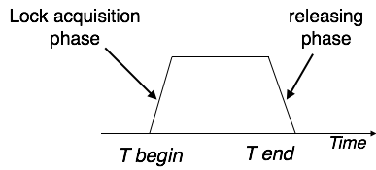

Two-phase locking has two phases, one is **growing**, where all the locks are being acquired by the transaction; and the second phase is shrinking, where the locks held by the transaction are being released.

To claim an exclusive (write) lock, a transaction must first acquire a shared (read) lock and then upgrade it to an exclusive lock.

**Strict Two-Phase Locking**

The first phase of Strict-2PL is same as 2PL. After acquiring all the locks in the first phase, the transaction continues to execute normally. But in contrast to 2PL, Strict-2PL does not release a lock after using it. Strict-2PL holds all the locks until the commit point and releases all the locks at a time.

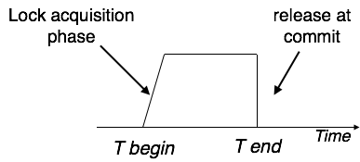

Strict-2PL does not have cascading abort as 2PL does.

1. **Timestamp-based Protocols**

The most commonly used concurrency protocol is the timestamp based protocol. This protocol uses either system time or logical counter as a timestamp.

Lock-based protocols manage the order between the conflicting pairs among transactions at the time of execution, whereas timestamp-based protocols start working as soon as a transaction is created.

Every transaction has a timestamp associated with it, and the ordering is determined by the age of the transaction. A transaction created at 0002 clock time would be older than all other transactions that come after it. For example, any transaction 'y' entering the system at 0004 is two seconds younger and the priority would be given to the older one.

In addition, every data item is given the latest read and write-timestamp. This lets the system know when the last ‘read and write’ operation was performed on the data item.

**Timestamp Ordering Protocol**

The timestamp-ordering protocol ensures serializability among transactions in their conflicting read and write operations. This is the responsibility of the protocol system that the conflicting pair of tasks should be executed according to the timestamp values of the transactions.

* The timestamp of transaction Ti is denoted as TS(Ti).
* Read time-stamp of data-item X is denoted by R-timestamp(X).
* Write time-stamp of data-item X is denoted by W-timestamp(X).

Timestamp ordering protocol works as follows −

* **If a transaction Ti issues a read(X) operation −**
  + If TS(Ti) < W-timestamp(X)
    - Operation rejected.
  + If TS(Ti) >= W-timestamp(X)
    - Operation executed.
  + All data-item timestamps updated.
* **If a transaction Ti issues a write(X) operation −**
  + If TS(Ti) < R-timestamp(X)
    - Operation rejected.
  + If TS(Ti) < W-timestamp(X)
    - Operation rejected and Ti rolled back.
  + Otherwise, operation executed.

**Thomas' Write Rule**

This rule states if TS(Ti) < W-timestamp(X), then the operation is rejected and Ti is rolled back.

Time-stamp ordering rules can be modified to make the schedule view serializable.

Instead of making Ti rolled back, the 'write' operation itself is ignored.

In a multi-process system, deadlock is an unwanted situation that arises in a shared resource environment, where a process indefinitely waits for a resource that is held by another process.

For example, assume a set of transactions {T0, T1, T2, ...,Tn}. T0 needs a resource X to complete its task. Resource X is held by T1, and T1 is waiting for a resource Y, which is held by T2. T2 is waiting for resource Z, which is held by T0. Thus, all the processes wait for each other to release resources. In this situation, none of the processes can finish their task. This situation is known as a deadlock.

Deadlocks are not healthy for a system. In case a system is stuck in a deadlock, the transactions involved in the deadlock are either rolled back or restarted.

**Deadlock Prevention**

To prevent any deadlock situation in the system, the DBMS aggressively inspects all the operations, where transactions are about to execute. The DBMS inspects the operations and analyzes if they can create a deadlock situation. If it finds that a deadlock situation might occur, then that transaction is never allowed to be executed.

There are deadlock prevention schemes that use timestamp ordering mechanism of transactions in order to predetermine a deadlock situation.

**Wait-Die Scheme**

In this scheme, if a transaction requests to lock a resource (data item), which is already held with a conflicting lock by another transaction, then one of the two possibilities may occur −

* If TS(Ti) < TS(Tj) − that is Ti, which is requesting a conflicting lock, is older than Tj − then Ti is allowed to wait until the data-item is available.
* If TS(Ti) > TS(tj) − that is Ti is younger than Tj − then Ti dies. Ti is restarted later with a random delay but with the same timestamp.

This scheme allows the older transaction to wait but kills the younger one.

**Wound-Wait Scheme**

In this scheme, if a transaction requests to lock a resource (data item), which is already held with conflicting lock by some another transaction, one of the two possibilities may occur −

* If TS(Ti) < TS(Tj), then Ti forces Tj to be rolled back − that is Ti wounds Tj. Tj is restarted later with a random delay but with the same timestamp.
* If TS(Ti) > TS(Tj), then Ti is forced to wait until the resource is available.

This scheme, allows the younger transaction to wait; but when an older transaction requests an item held by a younger one, the older transaction forces the younger one to abort and release the item.

In both the cases, the transaction that enters the system at a later stage is aborted.

**Deadlock Avoidance**

Aborting a transaction is not always a practical approach. Instead, deadlock avoidance mechanisms can be used to detect any deadlock situation in advance. Methods like "wait-for graph" are available but they are suitable for only those systems where transactions are lightweight having fewer instances of resource. In a bulky system, deadlock prevention techniques may work well.

**Wait-for Graph**

This is a simple method available to track if any deadlock situation may arise. For each transaction entering into the system, a node is created. When a transaction Ti requests for a lock on an item, say X, which is held by some other transaction Tj, a directed edge is created from Ti to Tj. If Tj releases item X, the edge between them is dropped and Ti locks the data item.

The system maintains this wait-for graph for every transaction waiting for some data items held by others. The system keeps checking if there's any cycle in the graph.

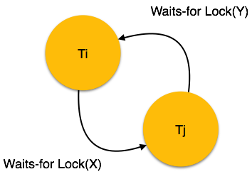

Here, we can use any of the two following approaches −

* First, do not allow any request for an item, which is already locked by another transaction. This is not always feasible and may cause starvation, where a transaction indefinitely waits for a data item and can never acquire it.
* The second option is to roll back one of the transactions. It is not always feasible to roll back the younger transaction, as it may be important than the older one. With the help of some relative algorithm, a transaction is chosen, which is to be aborted. This transaction is known as the **victim** and the process is known as **victim selection**.